**Oracle EBS Payables Assignment**

**Date : 06th Dec 2024:**

**Each & Every assignment needs to explain with necessary screen shots.**

**Name:**

1. **Create an Invoice Standard: [Payment team: Immediate].**

Path

Login to Oracle EBS > Switch to Payables, Vision Operations (USA) Responsibility 

Invoices -> Entry -> Invoices

Enter the invoice information

Save 

1. **Validate the Invoice:**
   * Validate the invoice you just created to ensure there are no errors and it's ready for payment.

* Validate the Invoice
  + Actions -> Validate -> Ok
  + A screenshot of a computer

    Description automatically generated
* Correct the validation holds
  + A screenshot of a computer

    Description automatically generated
  + Adjust header information to match the tax adjusted line information
  + A screenshot of a computer

    Description automatically generated
* Revalidate
  + Actions -> Validate -> Ok
  + A screenshot of a computer

    Description automatically generated

1. **Do Create Accounting & Transfer to General Ledger:**

Actions -> Create Accounting -> Final Post -> Ok

1. **Create A debit Memo** (Validate & Create accounting) .. Explain each & every step with screen shot.

Path

Login to Oracle EBS > Switch to Payables, Vision Operations (USA) Responsibility 

Invoices -> Entry -> Invoices

* Enter the debit memo information
  + A screenshot of a computer

    Description automatically generated
  + 
  + 
  + A screenshot of a computer

    Description automatically generated
* Save 
* Validate the Invoice
  + Actions -> Validate -> Ok
  + A screenshot of a computer

    Description automatically generated
* Correct the validation holds
  + 
  + Adjust header information to match the tax adjusted line information
  + A screenshot of a computer

    Description automatically generated
* Revalidate
  + Actions -> Validate -> Ok
  + A screenshot of a computer

    Description automatically generated
* If the revalidation is successful, generate the accounting information and post to GL
  + Actions -> Create Accounting -> Final Post -> Ok
  + A screenshot of a computer

    Description automatically generated

The debit memo has now been created and the accounting information has been posted to the GL.

1. **Create a Credit Memo** (Validate & Create accounting) .. Explain each & every step with screen shot.

Path

Login to Oracle EBS > Switch to Payables, Vision Operations (USA) Responsibility 

Invoices -> Entry -> Invoices

* Enter the credit memo information
  + A screenshot of a computer

    Description automatically generated
  + 
  + 
  + A screenshot of a computer

    Description automatically generated
* Save 
* Validate the Invoice
  + Actions -> Validate -> Ok
  + A screenshot of a computer

    Description automatically generated
* Correct the validation holds
  + 
  + Adjust header information to match the tax adjusted line information
  + A screenshot of a computer

    Description automatically generated
* Revalidate
  + Actions -> Validate -> Ok
  + A screenshot of a computer

    Description automatically generated
* If the revalidation is successful, generate the accounting information and post to GL
  + Actions -> Create Accounting -> Final Post -> Ok
  + A screenshot of a computer

    Description automatically generated

The credit memo has now been created and the accounting information has been posted to the GL.

1. **Query a PO based Invoice & check the Po match details.**

Path

Login to Oracle EBS > Switch to Payables, Vision Operations (USA) Responsibility 

Invoices -> Entry -> Invoices

Perform a Wildcard Search for the PO Number

* Press F11
* Enter a “%” into the “PO Number” field
  + A screenshot of a computer

    Description automatically generated
* Press CTRL + F11
* The system will return the invoices with PO Numbers
  + A screenshot of a computer

    Description automatically generated

Match the PO Details

Path

Login to Oracle EBS > Switch to Purchasing, Vision Operations (USA) Responsibility 

Purchase Orders -> Purchase Orders

Query the Purchase Order

* Press F11
* Enter “4806” into the “PO” field
  + A screenshot of a computer

    Description automatically generated
* Press CTRL + F11
* A screenshot of a computer

  Description automatically generated

You can see that the PO details match the Invoice above.

1. **Create a PRE-Payment Invoice [Temporary].**

Path

Login to Oracle EBS > Switch to Payables, Vision Operations (USA) Responsibility 

Invoices -> Entry -> Invoices

* Enter the pre-payment invoice information
  + A screenshot of a computer

    Description automatically generated
  + 
  + 
  + A screenshot of a computer

    Description automatically generated
* Save 
* Validate the Invoice
  + Actions -> Validate -> Ok
  + A screenshot of a computer

    Description automatically generated
* Correct the validation holds
  + 
  + Adjust header information to match the tax adjusted line information
  + A screenshot of a computer

    Description automatically generated
* Revalidate
  + Actions -> Validate -> Ok
  + A screenshot of a computer

    Description automatically generated
* If the revalidation is successful, generate the accounting information and post to GL
  + Actions -> Create Accounting -> Final Post -> Ok
  + A screenshot of a computer

    Description automatically generated

The pre-payment invoice has now been created and the accounting information has been posted to the GL.

1. **Make single Payment for Standard Invoice** 
   * Navigate to the **Payments** window.

Path

Login to Oracle EBS > Switch to Payables, Vision Operations (USA) Responsibility 

Invoices -> Entry -> Invoices

* + Create a payment for the invoice

Login to Oracle EBS > Switch to Payables, Vision Operations (USA) Responsibility 

Pay the Invoice

* Actions -> Pay in Full… -> Ok
  + A screenshot of a computer

    Description automatically generated
* The Payments Workbench will open
  + A screenshot of a computer

    Description automatically generated
* Enter any missing information
  + A close up of a date

    Description automatically generated
  + A screen shot of a computer

    Description automatically generated
* Save 
* Create accounting and post to GL
  + Actions -> Create Accounting -> Final Post -> Ok
  + 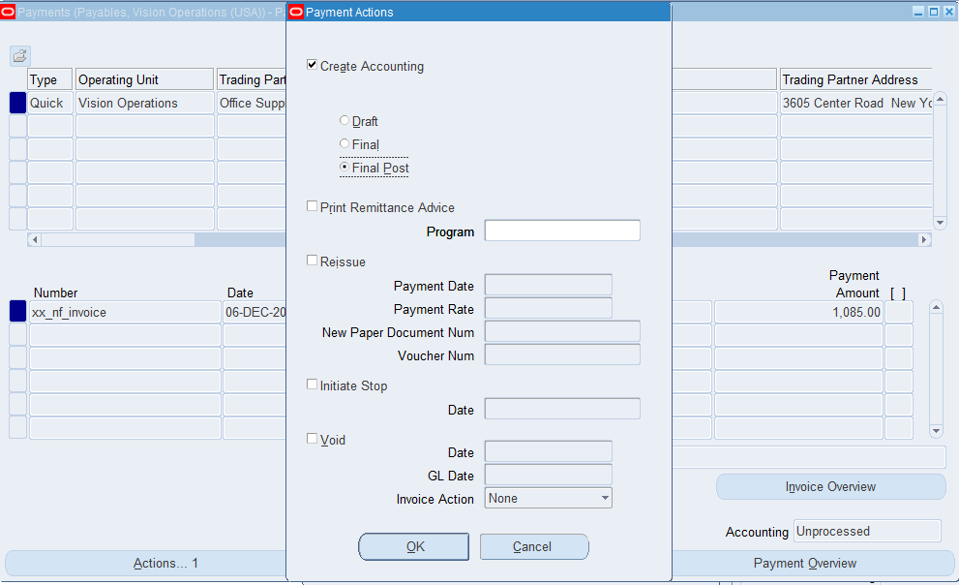
  + A screenshot of a computer

    Description automatically generated
* Print Remittance Advice
  + Actions -> Print Remittance Advice -> Ok
  + A screenshot of a computer

    Description automatically generated
  + A screenshot of a computer

    Description automatically generated

The payment has now been authorized.

Document Number: 100007

1. **Review Payment Status:**
   * Check the payment status in the **Payments** window.

Path

Login to Oracle EBS > Switch to Payables, Vision Operations (USA) Responsibility 

Payments -> Entry -> Payments

Query the Payment

* Press F11
* Enter “100007” into the “Document Number” field
  + A screenshot of a computer

    Description automatically generated
* Click “Payments Overview”
* The payment information will be displayed
  + A screenshot of a computer

    Description automatically generated
* The payment status is “Negotiable”
  + Verify that the payment has been successfully processed and issued.

Path

Login to Oracle EBS > Switch to Cash Management, Vision Operations (USA) Responsibility 

View -> Payments

Query the Payment

* Enter the Payment Information
  + A screenshot of a computer

    Description automatically generated
* Click “Find”
  + A screenshot of a computer

    Description automatically generated

Cash Management is the module where the payments authorized in the Payables Module are authorized, so this is one way to verify that the payment was made.

1. **Review the Accounting Entries:**
   * Review the accounting entries for the invoice and payment.

Path

Login to Oracle EBS > Switch to Payables, Vision Operations (USA) Responsibility 

Accounting -> Subledger Accounting -> Journal Entries

Search for the journal

* Enter the relevant Journal Information
  + A screenshot of a computer

    Description automatically generated
* Click “Go”
  + A screenshot of a computer

    Description automatically generated
* Click the ledger name under the “Ledger” column to bring up the journal details
  + A screenshot of a computer

    Description automatically generated
  + Ensure that the correct debits and credits are applied to the appropriate accounts (e.g., Expense and Bank accounts).

The credits and debits above match the line items in the invoice, and the credits and debits match, following correct accounting convention.

1. **In Invoice Work -Bench how many types of Invoices are there?**

There are 8 types of invoice, as shown above.

1. **Troubleshoot a Payables Issue: Hold**Invoice line level variances [Hold] Release hole with Invoice Re-Validation

In the invoice workbench, the holds tab is the third tab shown:

This view shows holds for the invoice that must be corrected and released before the invoice can be fully validated.

The hold we’ve seen most commonly in this assignment is the following hold:

**Hold Name**: Line Variance

**Hold Reason**: Total of Invoice Lines does not equal Invoice Amount

This hold is the result of the header amount not matching the line amount, as shown here from one of the previous questions:

As you can see, to resolve the hold, we need to correct the header amount to match the new lines total.

Once the hold issue has been resolved, you can re-validate to confirm that the invoice is now correct.

1. **In the PAYMENT Work Bench query the payment Document # (the Payment which you have done for Standard Invoice.**

Path

Login to Oracle EBS > Switch to Payables, Vision Operations (USA) Responsibility 

Payments -> Entry -> Payments

Query the Payment

* Press F11
* Enter “100007” into the “Document Number” field
* Press CTRL + F11
* The Payment will be displayed
  + A screenshot of a computer

    Description automatically generated

1. **Review the Payment accounting details.**

Path

Login to Oracle EBS > Switch to Payables, Vision Operations (USA) Responsibility 

Accounting -> Subledger Accounting -> Journal Entries

Search for the journal

* Enter the relevant Journal Information
  + A screenshot of a computer

    Description automatically generated
* Click “Go”
  + A screenshot of a computer

    Description automatically generated
* Click the ledger name under the “Ledger” column to bring up the journal details

**Cash Management:**

1. **Review the Bank account Details (Disbursement Bank) which you use for Payment.**

Path

Login to Oracle EBS > Switch to Cash Management, Vision Operations (USA) Responsibility 

View -> Bank Accounts

Query the Payment

* Enter the Bank Account Information
  + A screenshot of a computer

    Description automatically generated
* Click “Go”
* Under “Account Name” click on the bank account of interest
  + 
* The bank account information will be shown, including the Cash Clearing account, which is used for reconciliation
  + A screenshot of a computer

    Description automatically generated